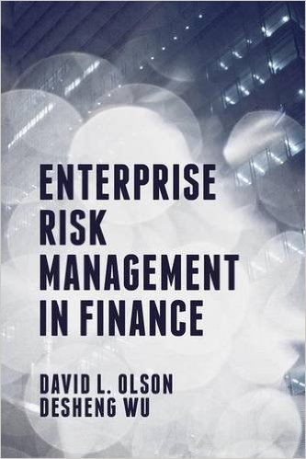
Part 1: Perspectives

Chapter 1: Introduction of Enterprise Risk Management in Finance
Introduction
Crisis, Globalization and risk
History of ERM in Finance
What is ERM in Finance?
Types of Financial Risk
A framework for financial risk management
Conclusions

Chapter 2: The Financial Risk Perspective
2.1 Recent Financial Risks
2.2 Enterprise Risk Management in Banking
2.2.1 The Basel Accords
2.3. Enterprise Risk Management in Insurance
2.3.1 The Basel Accords
2.4 Measuring Market Risk
2.4.1 VaR – Value at risk
2.4.2 Historical simulation
2.4.3 Variance-covariance approach
2.4.4 Scenario analysis
2.4.5 CVaR
2.5 Measuring Credit Risk
2.6 Measuring Operational Risk
2.7 Conclusions

Chapter 3: The Insurance Perspective
3.1 Sarbanes Oxley
3.2 The COSO Framework
3.2.1 Categories
3.2.2 Activities
3.3 Risk Appetite
3.4 Conclusions

Chapter 4: Sustainable investment
4.1 Sustainable investment market
4.2 Modeling
4.3 Index tracking
4.4 Demonstration, Computation
4.5 Conclusions

Part II: Tools

Chapter 5: Banking performance analysis
5.1 Chain perspective of Banking Operations
5.2 Efficiency Analysis
5.2.1 DEA, Return to Scale
5.2.2 Data mining
5.2.3 Decision support
5.2.4 Modeling
5.2.5 Emergency management support systems
5.3 Conclusions

Chapter 6: Stock market forecast
6.1 Demonstration of market evolution
6.2 Volatility modeling
5.2.1 GARCH
5.2.2 Neural networks
5.2.3 Modeling
5.2.3 Data analysis
6.3 Conclusion

Chapter 7: Financial sentiment analysis
7.1 Construction of sentiment
7.2 Text mining and sentiment for stock market analysis
7.3 Demonstration
7.4 Conclusions

Chapter 8: Catastrophe bond and risk modeling
8.1 Bond market
8.2 Catastrophe bond
8.3 Jump Diffusion, Simulation Modeling
8.4 Demonstration, Computation
8.5 Conclusions

Chapter 9: Credit Risk Analysis
9.1 Lorenz Curve,
9.3 Beacon, credit bureau and internal banking
9.4 accounts receivable, Credit rating
9.5 Conclusions

Part III: Cases
Chapter 10: Financial Risk Case
Chapter 11: Insurance Risk Case
Chapter 12: Real option Case

