Decison Making With Uncertainty And Data Mining

David L. Olson
Department of Management
University of Nebraska
Lincoln, NE 68588-0491
(402) 472-4521
FAX: (402) 472-5855
Dolson3@unl.edu

Desheng Wu* (corresponding author)
School of Business
University of Science and Technology of China
Hefei Anhui 230026 P.R. China
dash@ustc.edu

Keywords: Multiple attribute decision making (MADM); data mining; uncertainty ; Fuzzy sets; Monte Carlo simulation;

Abstract.
Data mining is a newly developed and emerging area of computational intelligence that offers new theories, techniques, and tools for analysis of large data sets. It is expected to offer more and more support to modern organizations which face a serious challenge of how to make decision from massively increased information so that they can better understand their markets, customers, suppliers, operations and internal business processes. This paper discusses fuzzy decision-making using the Grey Related Analysis method. Fuzzy models are expected to better reflect decision maker uncertainty, at some cost in accuracy relative to crisp models. Monte Carlo Simulation, a data mining technique, is used to measure the impact of fuzzy models relative to crisp models. Fuzzy models were found to provide fits as good as crisp models in the data analyzed.

1. Introduction

Data mining is a newly developed and emerging area of computational intelligence that offers new theories, techniques, and tools for analysis of large data sets. This emerging development corresponds to the current needs of information intensive organizations transform themselves from passive collectors to active explorers and exploiters of data. Modern organizations face a serious challenge that is how they should make decisions from massively increased information so that they can better understand their markets, customers, suppliers, operations and internal business processes. The field of data mining aims to improve decision making by focusing on discovering valid, comprehensible, and potentially useful knowledge from large data sets.
This paper presents a brief demonstration of the use of Monte Carlo simulation in grey related analysis. Simulation provides a means to more completely describe expected results, to include identification of the probability of a particular option being best in a multiattribute setting. The next section describes a Monte Carlo simulation of results of decision tree analysis of real credit card data. Monte Carlo simulation provides a means to more completely assess relative performance of alternative decision tree models. Relative performance of crisp and fuzzy decision tree models is assessed in the conclusions.

2. Simulation of Grey Related Analysis
Multiattribute decision making with uncertainty has progressed in a variety of directions throughout the world, which greatly enrich the development of probability theory [8], fuzzy theory [4], rough sets[7], grey sets[3] and vague sets [9]. The basic multiattribute model can be written as follows:
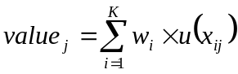 (1)
where w_{i} is the weight of attribute i, K is the number of attributes, and u(x_{ij}) is the score of alternative x_{j} on attribute i. Real life decisions usually involve high levels of uncertainty which can be reflected in the development of multiattribute models. Decision making methods with uncertain input in the form of fuzzy sets and rough sets have been widely published in both multiattribute decision making [1] and in data mining [2, 5]. The method of grey analysis [3] is another approach reflecting uncertainty into the basic multiattribute model. This paper discusses the use of a common data analysis technique, i.e, Monte Carlo Simulation, to this model to reflect uncertainty as expressed by fuzzy inputs. While this example is on a small data set, it can be extended to large data sets in data mining contexts as well. Monte Carlo simulation thus provides an efficient way to analyze grey analysis data.
Grey related analysis is a decision making technique which can be used to deal with uncertainty in forms of fuzzy data. Suppose that a multiple attribute decision making problem with interval numbers has m feasible plans 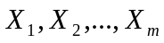, n indexes, weight value 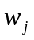 of index 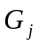 is uncertain, but we know 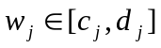 , 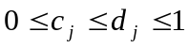，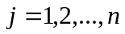，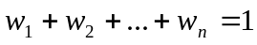, and the index value of j-th index of feasible plan 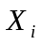 is an interval number 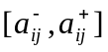,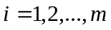，. When 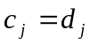，, the multiple attribute decision making problem with interval numbers is called a multiple attribute decision making problem with interval-valued indexes; When 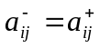，， , the multiple attribute decision making problem with interval numbers is called a multiple attribute decision making problem with interval-valued weights. Now the principle and steps of the Grey Related Analysis method are demonstrated by the following case illustration.
Consider the following problem consisting of six applicants for a position, each evaluated over seven attributes. Attributes are Experience in the Business Area(C1), Experience in the Specific Job Function(C2), Educational Background(C3), Leadership Capacity(C4), Adaptability(C5), Age(C6), Aptitude for Teamwork(C7). Raw data is provided in the form of trapezoidal data, which can be converted to an interval value using -cut technology to build a membership function [4]. In this case, using an of 0.5, we obtain the data in Table 1:
Table 1: Interval Data
weights | [0.20 0.35] | [0.30 0.55] | [0.05 0.30] | [0.25 0.50] | [0.15 0.45] | [0.05 0.30] | [0.25 0.55]
Performance | C1 | C2 | C3 | C4 | C5 | C6 | C7
Antônio | [0.65 0.85] | [0.75 0.95] | [0.25 0.45] | [0.45 0.85] | [0.05 0.45] | [0.45 0.75] | [0.75 1.00]
Fábio | [0.25 0.45] | [0.05 0.25] | [0.65 0.85] | [0.30 0.65] | [0.30 0.75] | [0.05 0.25] | [0.05 0.45]
Alberto | [0.45 0.65] | [0.20 0.80] | [0.65 0.85] | [0.50 0.80] | [0.35 0.90] | [0.20 0.45] | [0.75 1.00]
Fernando | [0.85 1.00] | [0.35 0.75] | [0.65 0.85] | [0.15 0.65] | [0.30 0.70] | [0.45 0.80] | [0.35 0.70]
Isabel | [0.50 0.95] | [0.65 0.95] | [0.45 0.65] | [0.65 0.95] | [0.05 0.50] | [0.45 0.80] | [0.50 0.90]
Rafaela | [0.65 0.85] | [0.15 0.35] | [0.45 0.65] | [0.25 0.75] | [0.05 0.45] | [0.45 0.80] | [0.10 0.55]

All of these index values are positive. The next step of the grey related method is to standardize the interval decision matrix. This step is omitted since our data is already on a 0-1 range. Next we need to calculate the interval number weighted matrix C denoted as 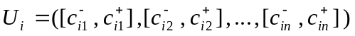, which consists of the minimum weight times the minimum alternative performance score for each entry as the left element of the interval number, and the maximum weight times the maximum alternative performance score for each entry as the right element of that entry’s interval number. The weighted matrix C is shown in Table 2.
Table 2: Weighted Matrix C
Performance | C1 | C2 | C3 | C4 | C5 | C6 | C7
Antônio | [0.13 0.30] | [0.22 0.52] | [0.01 0.14] | [0.11 0.43] | [0.01 0.20] | [0.02 0.23] | [0.18 0.55]
Fábio | [0.05 0.16] | [0.01 0.14] | [0.03 0.26] | [0.07 0.33] | [0.04 0.34] | [0.00 0.08] | [0.01 0.25]
Alberto | [0.09 0.23] | [0.06 0.44] | [0.03 0.26] | [0.12 0.40] | [0.05 0.41] | [0.01 0.14] | [0.18 0.55]
Fernando | [0.17 0.35] | [0.10 0.41] | [0.03 0.26] | [0.03 0.33] | [0.04 0.32] | [0.02 0.24] | [0.09 0.39]
Isabel | [0.10 0.33] | [0.19 0.52] | [0.02 0.20] | [0.16 0.48] | [0.01 0.23] | [0.02 0.24] | [0.12 0.50]
Rafaela | [0.13 0.30] | [0.04 0.19] | [0.02 0.20] | [0.06 0.38] | [0.01 0.20] | [0.02 0.24] | [0.02 0.30]

The next step of the grey related method is to obtain reference number sequences based on the optimal weighted interval number value for every alternative. This is defined as the interval number for each attribute defined as the maximum left interval value over all alternatives, and the maximum right interval value over all alternatives. For C1, this would yield the interval number [0.17, 0.35]. This reflects the maximum weighted value obtained in the data set for attribute C1. Table 3 gives this vector, which reflects the range of value possibilities (entries are not rounded):

Table 3: Reference Number Vector
 | C1 | C2 | C3 | C4 | C5 | C6 | C7
Max(Min) | 0.1700 | 0.2250 | 0.0325 | 0.1625 | 0.0525 | 0.0225 | 0.1875
Max(Max) | 0.3500 | 0.5225 | 0.2550 | 0.4750 | 0.4050 | 0.2400 | 0.5500

Distances are defined as the maximum between each interval value and the extremes generated. Table 4 shows the calculated distances by alternative.

Table 4: Distances From Alternatives to Reference Number Vector
Distances | C1 | C2 | C3 | C4 | C5 | C6 | C7
Antônio | [.04, .0525] | [0, 0] | [.02, .12] | [.05, .05] | [.045, .2025] | [0, .015] | [0, 0]
Fábio | [.12, .1925] | [.21, .385] | [0, 0] | [.0875, .15] | [.0075, .0675] | [.02, .165] | [.175, .3025]
Alberto | [.08, .1225] | [.165, .0825] | [0, 0] | [.0375, .075] | [0, 0] | [.0125, .105] | [0, 0]
Fernando | [0, 0] | [.12, .11] | [0, 0] | [.125, .15] | [.0075, .09] | [0, 0] | [.1, .165]
Isabel | [.07, .0175] | [.03, 0] | [.01, .06] | [0, 0] | [.045, .18] | [0, 0] | [.0625, .055]
Rafaela | [.04, .0525] | [.18, .33] | [.01, .06] | [.1, .1] | [.045, .2025] | [0, 0] | [.1625, .2475]

The maximum distance for each alternative to the ideal is identified as the largest distance calculation in each cell of Table 4. These maxima are shown in Table 5.

Table 5: Maximum Distances
Distances | C1 | C2 | C3 | C4 | C5 | C6 | C7
Antônio | 0.0525 | 0 | 0.12 | 0.05 | 0.2025 | 0.015 | 0
Fábio | 0.1925 | 0.385 | 0 | 0.15 | 0.0675 | 0.165 | 0.3025
Alberto | 0.1225 | 0.165 | 0 | 0.075 | 0 | 0.105 | 0
Fernando | 0 | 0.12 | 0 | 0.15 | 0.09 | 0 | 0.165
Isabel | 0.07 | 0.03 | 0.06 | 0 | 0.18 | 0 | 0.0625
Rafaela | 0.0525 | 0.33 | 0.06 | 0.1 | 0.2025 | 0 | 0.2475

A reference point is established as the maximum of entries in each column of Table 7. This point has a minimum of 0 and a maximum of 0.3850. Thus the reference point is [0, 0.385]. Next the method calculates the maximum distance between the reference point and each of the Weighted Matrix C values. Based upon weight interval number standardizing index value of every plan and reference number sequence , the formula for this calculation is given as follows.
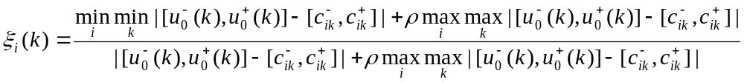
Where  (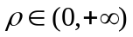) is called resolving coefficient. The smaller is, the greater its resolving power. In general, [0，1] .The value of may change according to the practical situation.

Results by alternative are given in Table 6:
Table 6: Weighted Distances to Reference Point
Distances | C1 | C2 | C3 | C4 | C5 | C6 | C7 | Averages
Antônio | 0.785714 | 1 | 0.616000 | 0.793814 | 0.487342 | 0.927711 | 1 | 0.801512
Fábio | 0.500000 | 0.333333 | 1 | 0.562044 | 0.740385 | 0.538462 | 0.388889 | 0.580445
Alberto | 0.611111 | 0.538462 | 1 | 0.719626 | 1 | 0.647059 | 1 | 0.788037
Fernando | 1 | 0.616000 | 1 | 0.562044 | 0.681416 | 1 | 0.538462 | 0.771132
Isabel | 0.733333 | 0.865169 | 0.762376 | 1 | 0.516779 | 1 | 0.754902 | 0.804651
Rafaela | 0.785714 | 0.368421 | 0.762376 | 0.658120 | 0.487342 | 1 | 0.437500 | 0.642782

The average 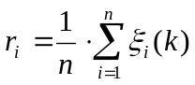 (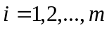) of these weighted distances is used as the reference number to order alternatives. These averages reflect how far away each alternative is from the nadir, along with how close they are to the ideal, much as in TOPSIS. This set of numbers indicates that Isabel is the preferred alternative, although Antônio is extremely close, with Alberto and Fernando close behind. This closeness demonstrates that the fuzzy input may reflect a case where there is not a clear winner. Simulation provides a tool capable of picking up the probability of each alternative being preferred.

3 Monte Carlo Simulation

To deal with both fuzzy weights and fuzzy alternative performance scores over attributes, we develop a Monte Carlo simulation model of this decision. The simulation was controlled, using ten unique seed values to ensure that the difference in simulation output due to random variation was the same for each alternative.

3.1 Trapezoidal Fuzzy Simulation
The trapezoidal fuzzy input dataset can also be simulated.

X is random number (0 < rn < 1)

Definition of trapezoid: a1 is left 0 in Figure 2
a2 is left 1
a3 is right 1
a4 is right 0

Contingent calculation: J is area of left triangle
K is area of rectangle
L is area of right triangle
Fuzzy sum = left triangle + rectangle + right triangle = 1

M is the area of the left triangle plus the rectangle (for calculation of X value)

X is the random number drawn (which is the area)

If X ≤ J:
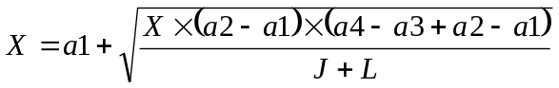 (8)

If J ≤ X ≤ J+K:

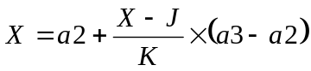 (9)

If J+K ≤ X:

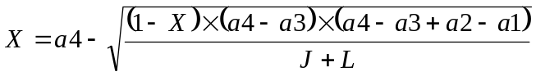 (10)

Our calculation is based upon drawing a random number reflecting the area (starting on the left (a1) as 0, ending on the right (a4) as 1), and calculating the distance on the X-axis. The simulation software Crystal Ball was used to replicate each model 1,000 times for each random number seed. The software enabled counting the number of times each alternative won. Probabilities given in Table 7 are thus simply the number of times each alternative had the highest value score divided by 1,000. This was done ten times, using different seeds. Therefore, mean probabilities and standard deviations (std) are based on 10,000 simulations. The Min and Max entries are the minimum and maximum probabilities in the ten replications shown in the table.

Table 7: Simulated Probabilities of Winning for Uniform Fuzzy Input

Trapezoidal | Antônio | Fábio | Alberto | Fernando | Isabel | Rafaela
seed1234 | 0.337 | 0.000 | 0.188 | 0.046 | 0.429 | 0.000
seed2345 | 0.381 | 0.000 | 0.168 | 0.040 | 0.411 | 0.000
seed3456 | 0.346 | 0.000 | 0.184 | 0.041 | 0.429 | 0.000
seed4567 | 0.357 | 0.000 | 0.190 | 0.046 | 0.407 | 0.000
seed5678 | 0.354 | 0.000 | 0.210 | 0.052 | 0.384 | 0.000
seed6789 | 0.381 | 0.000 | 0.179 | 0.046 | 0.394 | 0.000
seed7890 | 0.343 | 0.000 | 0.199 | 0.052 | 0.406 | 0.000
seed8901 | 0.328 | 0.000 | 0.201 | 0.045 | 0.426 | 0.000
seed9012 | 0.353 | 0.000 | 0.189 | 0.048 | 0.410 | 0.000
seed0123 | 0.360 | 0.000 | 0.183 | 0.053 | 0.404 | 0.000
min | 0.328 | 0.000 | 0.168 | 0.040 | 0.384 | 0.000
mean | 0.354 | 0.000 | 0.189 | 0.047 | 0.410 | 0.000
max | 0.381 | 0.000 | 0.210 | 0.053 | 0.429 | 0.000
std | 0.017 | 0.000 | 0.012 | 0.004 | 0.015 | 0.000

3.2. Analysis of Results
The results for each system were very similar. Differences were tested by t-test of differences in means by alternative. None of these difference tests were significant at the 0.95 level (two-tailed tests). This establishes that no significant difference in interval or trapezoidal fuzzy input was detected (and any that did appear would be a function of random numbers only, as we established an equivalent transformation). A recap of results is given in Table 8.

Table 8: Probabilities Obtained
 | Antônio | Fábio | Alberto | Fernando | Isabel | Rafaela
Grey-Related | - | - | - | - | X | -
Interval average | 0.358 | 0 | 0.189 | 0.047 | 0.410 | 0
Interval minimum | 0.336 | 0 | 0.168 | 0.040 | 0.384 | 0
Interval maximum | 0.393 | 0 | 0.210 | 0.053 | 0.429 | 0
Trapezoidal average | 0.354 | 0 | 0.189 | 0.044 | 0.409 | 0
Trapezoidal minimum | 0.328 | 0 | 0.171 | 0.035 | 0.382 | 0
Trapezoidal maximum | 0.381 | 0 | 0.206 | 0.051 | 0.424 | 0

Isabel still wins, but at a probability just over 0.4. Antônio was second with a probability just over 0.35, followed by Alberto at about 0.19 and Fernando at below 0.05. There was very little overlap among alternatives in this example. However, should such overlap exist, the simulation procedure shown would be able to identify it. As it is, Isabel still appears a good choice, but Antônio appears a strong alternative.
While this example is on a small set of data, the intent was to demonstrate what could be done in that context could be applied on large-scale data sets as well. Our proposal is unique to our knowledge, proposing the use of simulation to more fully use grey-related data that more accurately reflects the real problem. If this could be done with small-scale data sets, our contention is that it can also be done with large-scale data sets in a data mining context.
4. Grey Related Decision Tree Model
Grey related analysis is expected to provide improvement over crisp models by better reflecting the uncertainty inherent in many human analysts’ minds. Data mining models based upon such data are expected to be less accurate, but hopefully not by very much. However, grey related model input would be expected to be stabler under conditions of uncertainty where the degree of change in input data increased.
We applied decision tree analysis to a small set (1,000 observations total) of credit card data. Originally, there was one output variable (whether or not the account defaulted, a binary variable with 1 representing default, 0 representing no default) and 65 available explanatory variables. These variables were analyzed and 26 selected as representing ideas that might be important to predicting the outcome. The original data set was imbalanced, with 140 default cases and 860 not defaulting. Initial decision tree models were almost all degenerate, classifying all cases as not defaulting. When differential costs were applied, the reverse degenerate model was obtained (all cases predicted to default). Therefore, a new dataset containing all 140 default cases and 160 randomly selected not default cases was generated, from with 200 cases were randomly selected as a training set, with the remaining 100 cases used as a test set.
The explanatory variables included five binary variables and one categorical variable, with the remaining 20 being continuous. To reflect fuzzy input, each variable (except for binary variables) was categorized into three categories based upon analysis of the data, using natural cutoff points to divide each variable into roughly equal groups.
Decision tree models were generated using the data mining software PolyAnalyst. That software allows setting minimum support level (the number of cases necessary to retain a branch on the decision tree), and a slider setting to optimistically or pessimistically split criteria. Lower support levels allow more branches, as does the optimistic setting. Every time the model was run, a different decision tree was liable to be obtained. But nine settings were applied, yielding many overlapping models. Three unique decision trees were obtained, reflected in the output to follow. There were a total of eight explanatory variables used in these three decision trees. The same runs were made for the categorical data reflecting grey related input. Four unique decision trees were obtained, with formulas again given below. A total of seven explanatory variables were used in these four categorical decision trees.
These models were then entered into a Monte Carlo simulation (supported by Crystal Ball software). A perturbation of each input variable was generated, set at five different levels of perturbation. The intent was to measure the loss of accuracy for crisp and grey related models.
The model results are given in the seven model reports in the appendix. Since different variables were included in different models, it is not possible to directly compare relative accuracy as measured by fitting test data. However, the means for the accuracy on test data for each model given in Table 9 show that the crisp models declined in accuracy more than the categorical models. The column headings in Table 9 reflect the degree of perturbation simulated.

Table 9: Mean Model Accuracy
Model | Crisp | 0.25 | 0.50 | 1.00 | 2.00 | 3.00 | 4.00 | 0.25
Continuous 1 | 0.70 | 0.70 | 0.70 | .068 | 0.67 | 0.66 | 0.65 | 0.70
Continuous 2 | 0.67 | 0.67 | 0.67 | 0.67 | 0.67 | 0.66 | 0.66 | 0.67
Continuous 3 | 0.71 | 0.71 | 0.70 | 0.69 | 0.67 | 0.67 | 0.66 | 0.71
Continuous | 0.693 | 0.693 | 0.690 | 0.680 | .670 | 0.667 | 0.657 | 0.693
Categorical 1 | 0.70 | 0.70 | 0.68 | 0.67 | 0.66 | 0.66 | 0.65 | 0.70
Categorical 2 | 0.70 | 0.70 | 0.70 | 0.69 | 0.68 | 0.67 | 0.67 | 0.70
Categorical 3 | 0.70 | 0.70 | 0.70 | 0.69 | 0.69 | 0.68 | 0.67 | 0.70
Categorical 4 | 0.70 | 0.70 | 0.70 | 0.69 | 0.68 | 0.67 | 0.67 | 0.70
Categorical | 0.700 | 0.700 | 0.695 | 0.688 | 0.678 | 0.670 | 0.665 | 0.700

The fuzzy models were expected to be less accurate, but here they actually averages slightly better accuracy. This, however, can simply be attributed to different variables being used in each model. The one exception is that models Continuous 2 and Categorical 3 were based on one variable, V64, the balance-to-payment ratio. The cutoff generated by model Continuous 2 was 6.44 (if V64 was < 6.44, prediction 0), while the cutoff for Categorical 3 was 4.836 (if V64 was > 4.835, the category was “high”, and the decision tree model was that if V64 = “high”, prediction 1, else prediction 0). The fuzzy model here was actually better in fitting the test data (although slightly worse in fitting the training data). The important point of the numbers in Table 9 is that there clearly was greater degradation in model accuracy for the continuous models than for the categorical (grey related) models. This point is further demonstrated by the wider dispersion of the graphs in the appendix.

5. Conclusions
This paper has discussed the integration of grey-related analysis and decision making with uncertainty. Grey related analysis, a method for the multiattribute decision making problem, is demonstrated by a case study. Results based on Monte Carlo simulation as a data mining technique offers more insights to assist our decision making in fuzzy environments by incorporating probability interpretation. Analysis of decision tree models through simulation shows that there does appear to be less degradation in model fit for grey related (categorical) data than for decision tree models generated from raw continuous data. It must be admitted that this is a preliminary result, based on a relatively small data set of only one type of data. However, it is intended to demonstrate a point meriting future research. This decision making approach can be applied to large-scale data sets, expanding our ability to implement data mining and large-scale computing.

References

[1] T. Aouam, S.I. Chang, E.S. Lee, Fuzzy MADM: An outranking method, European Journal of Operational Research 145:2 (2003) 317-328.

[2] Y. Hu ,Chen, Ruey-Shun; Tzeng, Gwo-Hshiung. Finding fuzzy classification rules using data mining techniques. Pattern Recognition Letters Volume: 24, Issue: 1-3, January, 2003, pp. 509-519

[3] J.L. Deng, Control problems of grey systems. Systems and Controls Letters 5, 1982, 288-294.

[4] D. Dubois, H. Prade, Fuzzy Sets and Systems: Theory and Applications, New York: Academic Press, Inc., 1980.

[5] Pedrycz, Witold . Fuzzy set technology in knowledge discovery. Fuzzy Sets and Systems Volume: 98, Issue: 3, September 16, 1998, pp. 279-290

[6] Rocco S., Claudio M. A rule induction approach to improve Monte Carlo system reliability assessment. Reliability Engineering and System Safety Volume: 82, Issue: 1, October, 2003, pp. 85-92

[7] Pawlak, Z., Rough sets, International Journal of Information & Computer Sciences 11 (1982) 341 -356.

[8] Pearl, J., Probabilistic reasoning in intelligent systems, Networks of Plausible inference, Morgan Kaufmann, San Mateo,CA 1988.

[9] Gau W.L., Buehrer D.J.. Vague sets. IEEE Trans, Syst. Man, Cybern, 23(1993) 610-614
APPENDIX: Models and their results

Continuous Model 1:
IF(V64<6.44,N,IF(V58<1.54,Y,IF(V6<3.91,N,Y)))

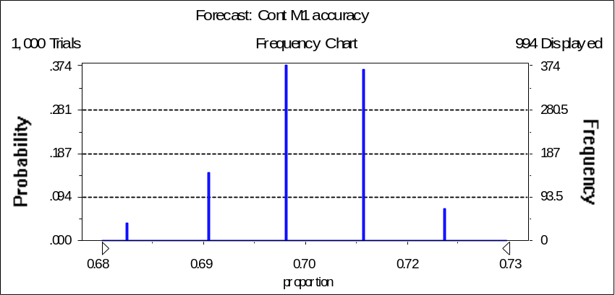

Test matrix:
 | Model 0 | Model 1 | Accuracy
Actual 0 | 43 | 16
Actual 1 | 14 | 27 | 0.70

Simulation accuracy of 100 observations, 1000 simulation runs
perturbation [-0.25,0.25] 0.67-0.73
perturbation [-0.50,0.50] 0.65-0.74
perturbation [-1,1] 0.62-0.75
perturbation [-2,2] 0.58-0.74
perturbation [-3,3] 0.57-0.74
perturbation [-4,4] 0.56-0.75

0.55 |  |  |  |  | 0.60 |  |  |  |  | 0.65 |  |  |  |  | 0.70 |  |  |  |  | 0.75

Continuous Model 2:
IF(V64<6.44,N,Y)

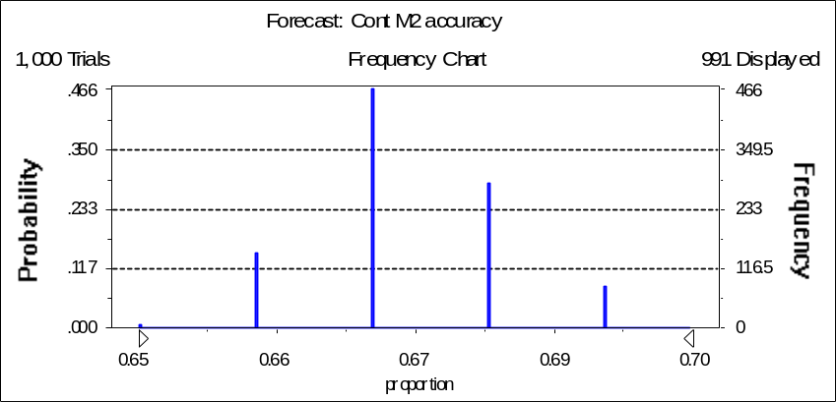

Test matrix:
 | Model 0 | Model 1 | Accuracy
Actual 0 | 40 | 19
Actual 1 | 14 | 27 | 0.67

Simulation accuracy of 100 observations, 1000 simulation runs
perturbation [-0.25,0.25] 0.65-0.71
perturbation [-0.50,0.50] 0.63-0.71
perturbation [-1,1] 0.60-0.74
perturbation [-2,2] 0.58-0.75
perturbation [-3,3] 0.55-0.78
perturbation [-4,4] 0.55-0.76

0.55 |  |  |  |  | 0.60 |  |  |  |  | 0.65 |  |  |  |  | 0.70 |  |  |  |  | 0.75
Continuous Model 3:
IF(V64<6.44,N,IF(V58<1.54,Y,IF(V63<2.28,Y,N)))

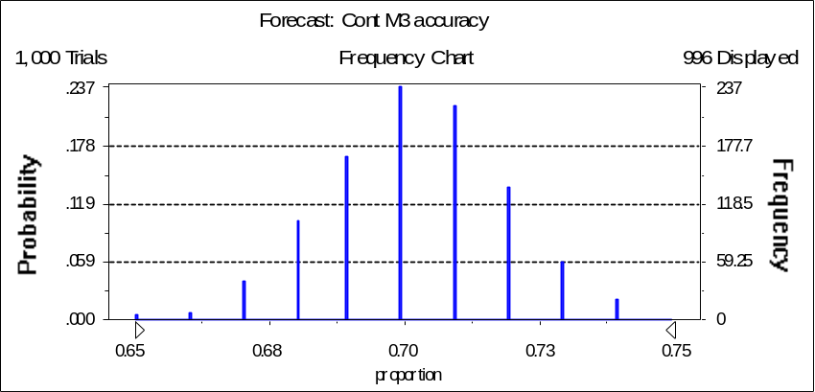

Test matrix:
 | Model 0 | Model 1 | Accuracy
Actual 0 | 44 | 15
Actual 1 | 14 | 27 | 0.71

Simulation accuracy of 100 observations, 1000 simulation runs
perturbation [-0.25,0.25] 0.65-0.76
perturbation [-0.50,0.50] 0.63-0.76
perturbation [-1,1] 0.59-0.77
perturbation [-2,2] 0.54-0.79
perturbation [-3,3] 0.53-0.78
perturbation [-4,4] 0.55-0.76

 |  | 0.55 |  |  |  |  | 0.60 |  |  |  |  | 0.65 |  |  |  |  | 0.70 |  |  |  |  | 0.75

Categorical Model 1:
IF(V64=”high”,IF(V54=”high”,if(V48=”mid”,N,Y),Y),N)

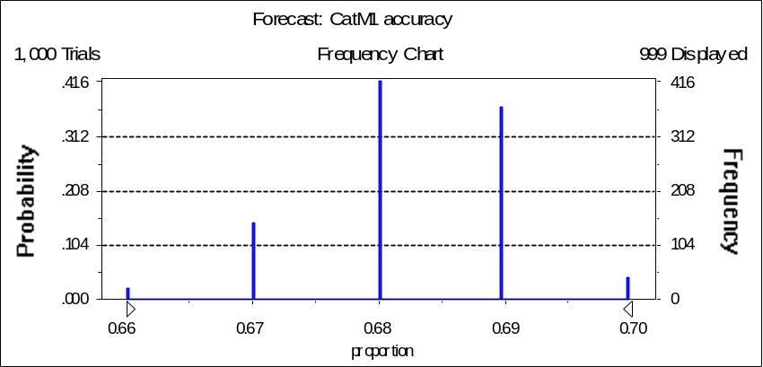

Test matrix:
 | Model 0 | Model 1 | Accuracy
Actual 0 | 33 | 26
Actual 1 | 5 | 36 | 0.70

Simulation accuracy of 100 observations, 1000 simulation runs
perturbation [-0.25,0.25] 0.66-0.71
perturbation [-0.50,0.50] 0.64-0.71
perturbation [-1,1] 0.61-0.71
perturbation [-2,2] 0.58-0.73
perturbation [-3,3] 0.56-0.74
perturbation [-4,4] 0.55-0.75

0.55 |  |  |  |  | 0.60 |  |  |  |  | 0.65 |  |  |  |  | 0.70 |  |  |  |  | 0.75
Categorical Model 2:
IF(V64=”high”,IF(V54=”low”,
IF(CDL=”mid”,IF(V37=”low”,Y,N),if(CDL=”low”,N,Y))
IF(V54=”high”,if(V48=”mid”,N,Y),Y),N)

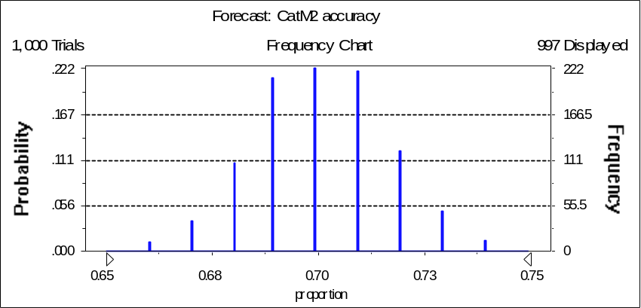

Test matrix:
 | Model 0 | Model 1 | Accuracy
Actual 0 | 42 | 17
Actual 1 | 13 | 28 | 0.70

Simulation accuracy of 100 observations, 1000 simulation runs
perturbation [-0.25,0.25] 0.65-0.75
perturbation [-0.50,0.50] 0.64-0.76
perturbation [-1,1] 0.61-0.76
perturbation [-2,2] 0.58-0.76
perturbation [-3,3] 0.57-0.80
perturbation [-4,4] 0.56-0.79

0.55 |  |  |  |  | 0.60 |  |  |  |  | 0.65 |  |  |  |  | 0.70 |  |  |  |  | 0.75 |  |  |  |  | 0.80

Categorical Model 3:
IF(V64=”high”,Y,N)

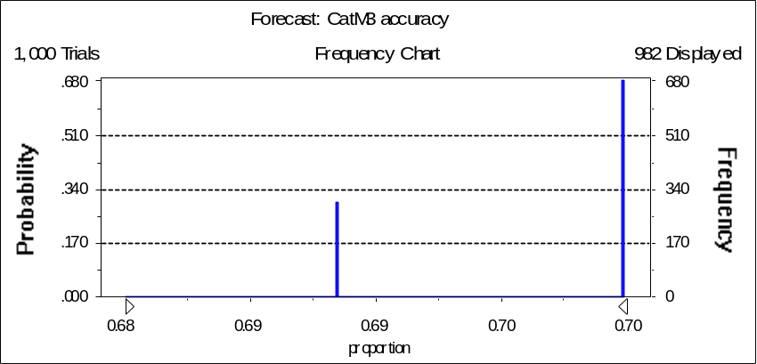
Test matrix:
 | Model 0 | Model 1 | Accuracy
Actual 0 | 33 | 26
Actual 1 | 4 | 37 | 0.70

Simulation accuracy of 100 observations, 1000 simulation runs
perturbation [-0.25,0.25] 0.68-0.70
perturbation [-0.50,0.50] 0.67-0.71
perturbation [-1,1] 0.66-0.72
perturbation [-2,2] 0.62-0.73
perturbation [-3,3] 0.59-0.75
perturbation [-4,4] 0.59-0.76

 | 0.60 |  |  |  |  | 0.65 |  |  |  |  | 0.70 |  |  |  |  | 0.75

Categorical Model 4:
IF(V64=”high”,
IF(V54=”low”,
IF(CDL=”mid”,IF(V37=”low”,Y,N),IF(CDL=”low”,IF(V61<.5,Y,N),Y))
IF(V54=”high”,IF(V48=”mid”,N,Y),Y)
,N)
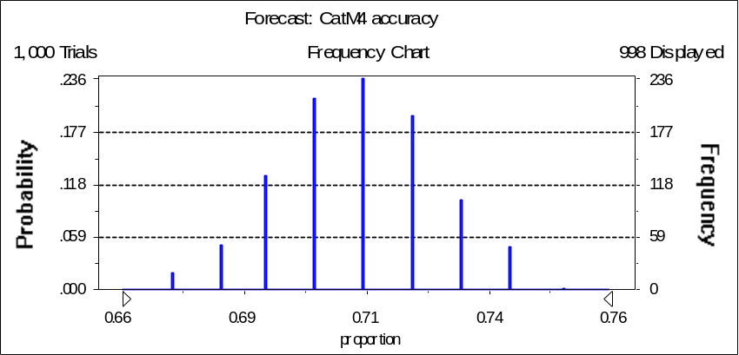
Test matrix:
 | Model 0 | Model 1 | Accuracy
Actual 0 | 41 | 18
Actual 1 | 12 | 29 | 0.70

Simulation accuracy of 100 observations, 1000 simulation runs
perturbation [-0.25,0.25] 0.65-0.76
perturbation [-0.50,0.50] 0.64-0.77
perturbation [-1,1] 0.61-0.77
perturbation [-2,2] 0.58-0.77
perturbation [-3,3] 0.57-0.77
perturbation [-4,4] 0.55-0.78

 | 0.55 |  |  |  |  | 0.60 |  |  |  |  | 0.65 |  |  |  |  | 0.70 |  |  |  |  | 0.75

